**Workshop C Format Overview**

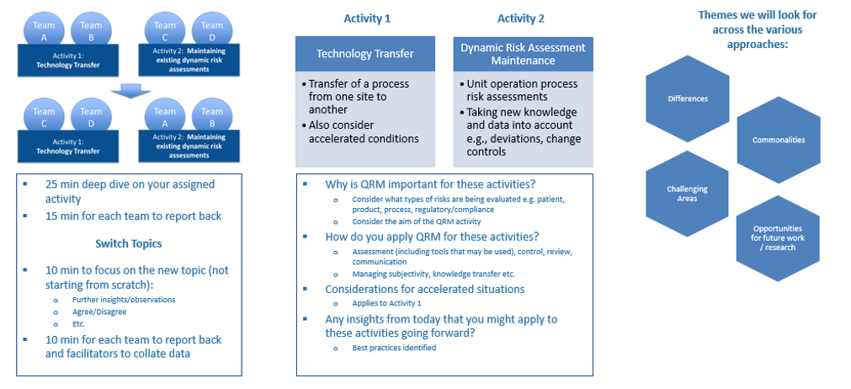

**QRM process as per ICH Q9**

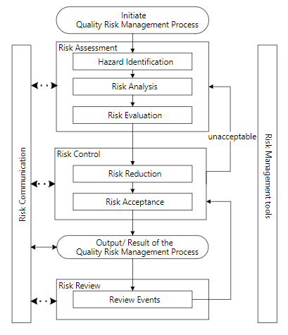

During the exercise consider:

* Risk Assessment (including tools/ methodologies)
* Risk Control
* Risk Communication
* Risk review
* Managing subjectivity and bias
* Use of data and knowledge
* Etc.

**Example Product Lifecycle**

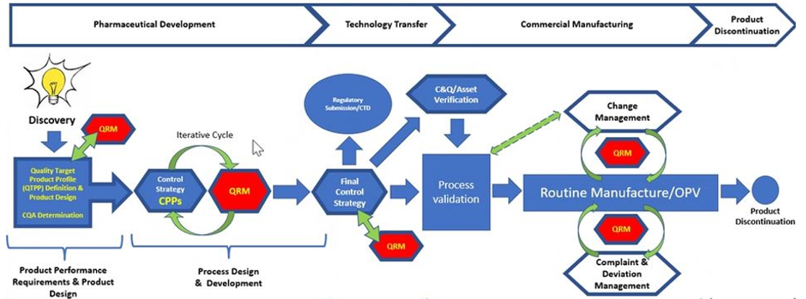

**ICH Q10 Pharmaceutical Quality System (PQS)**

