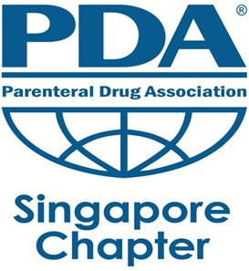 | Registration Form  Technical Symposium  Low Endotoxin Recovery  20th November 2015

Name of Participant: | Click here to enter text.
Designation: | Click here to enter text.
Company: | Click here to enter text.
Fee payable: | ☐ SGD 100 (member) ☐ SGD 150 (non-member)  ☐ SGD 135 (Government) ☐ SGD 30 (student)
Membership number: | Click here to enter text.
Choice of meal: | ☐ Vegetarian | ☐ Halal | ☐ NA
Means of payment:  (receipt will be provided once payment is confirmed) | ☐ Bank transfer (DBS Bank Singapore Acct no. 020 902240 4)  ☐ Cash  ☐ Check
Remarks: | Click here to enter text.

Bank Transfer information
Account Name: PDA Singapore Chapter
Account no.: 020 902240 4
Bank: DBS Bank
Bank Code: 7171
Branch Code: 020

